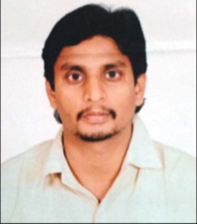
BIO-ATA

Designation : Assistant Professor

Department: COMPUTER SCIENCE AND ENGINEERING
- Name : SURESH GANNABATULA
- Date of Birth and Place of Birth : 11-06-1988
- Address for Communication : RUSTHUMBADA, NARSAPURAM
- Permanent Address : RUSTHUMBADA, NARSAPURAM
5. Mobile No : 9705747343
- Email-ID : sureshcsescet@gmail.com
- Educational Qualifications : MCA

Qualification | University/Board | Name of the College | Specialization | Year of Passing
PG | AU | SRI Y.N. COLLEGE | MCA | 2016
UG | B.SC | SRI Y.N. COLLEGE | M.P.C | 2010
ITI | BTE | NAGURJUNA INDUSTRIAL TRAINING INSTITITE | DM | 2007
INTERMEDIATE | BOI | SRI GOWTHAMI JR COLLEGE | M.P.C | 2005
SSC | SSC | Z.P.H. HIGH SCHOOL |  | 2003

- Teaching /Industry Experience :

S No | Designation | Organization | Total Exp. Years and Months
1 | Asst. Professor | Swarnandhra College Engineering & Technology | 3.11 Years

- Total Experience:
Teaching : 3.11 Years
Industry :
- Any other Distinctions/Achievements :
- Research Papers Published in Journals :
- Research Papers Published in Conferences
- Citations
- Workshops/STTP Attended :
- Workshops Conducted
- Details of Research Projects :
- Achievements :
- Strengths : Commitment, Hard working
- Other Details if any :
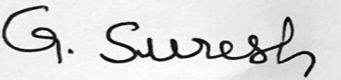

Signature of the Candidate

